**Drowsiness Detection System**

**Overview**

**What**

1. It is a Computer Vision Application aimed at detecting signs of fatigue or drowsiness in a person, especially while driving, to prevent accidents caused by falling asleep at the wheel.
2. This application can get data from various sources such as IP Camera, webcam and online video etc.
3. This is a web application which can be accessed over a LAN.
4. The IP camera is a wireless surveillance camera which can send footage to the wi-fi network to which it is connected, if the computer which contains the application is also connected with the same wi-fi network then we will be able to work on that footage data into our project and can detect mask.

**Why**

1. This application has many use cases such as Automotive Industry, Healthcare, Workplace Safety.
2. This kind of project shows Machine Learning knowledge, Programming skills and web development skills which can be very useful for resume perspective.
3. This project shows how you can solve real world problem with your knowledge.

**How**

1. **Backend**

|  |  |
| --- | --- |
| **Connection with IP camera** | OpenCV |
| **Face Detection** | OpenCV |
| **Mask Detection** | Keras, Numpy |
| **Save Data** | OpenCV |

1. **Frontend**

|  |  |
| --- | --- |
| **Web Application** | Streamlit |

**OpenCV**

1. Installing OpenCV package.

|  |
| --- |
| pip install opencv-python |

1. Code for OpenCV

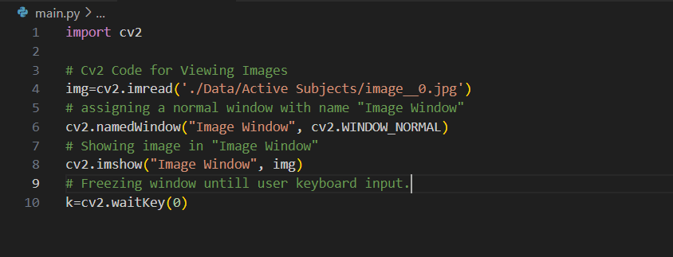

* Above code will represent Image (with given image path).

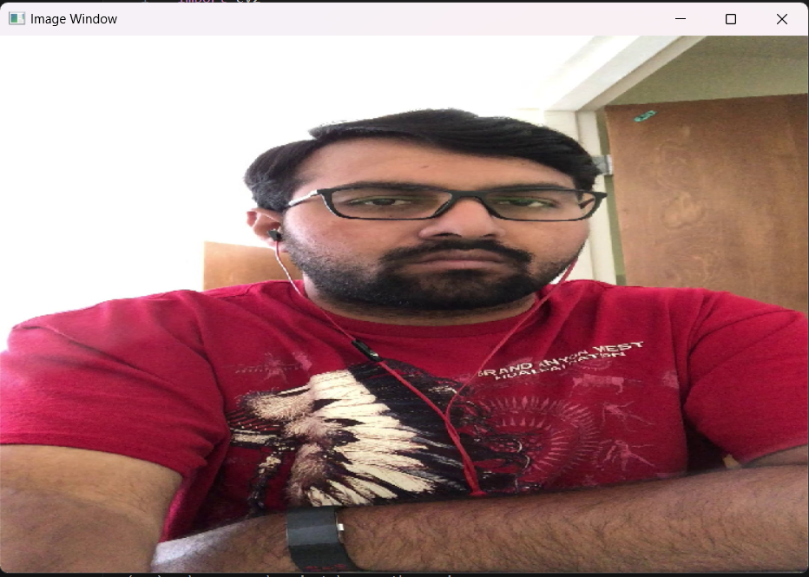

* Code for opening Video via IP Camera.

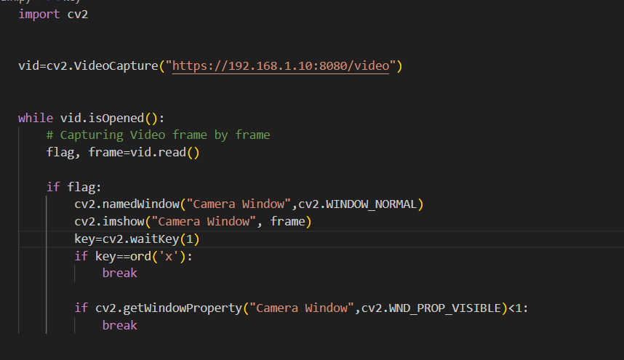

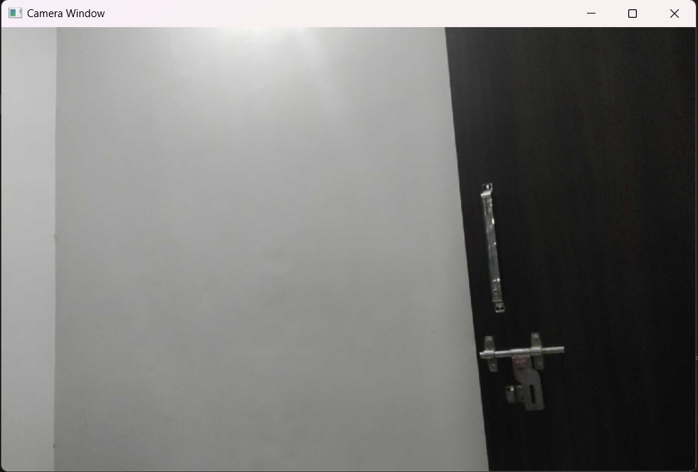

1. OpenCV code for Face Detection

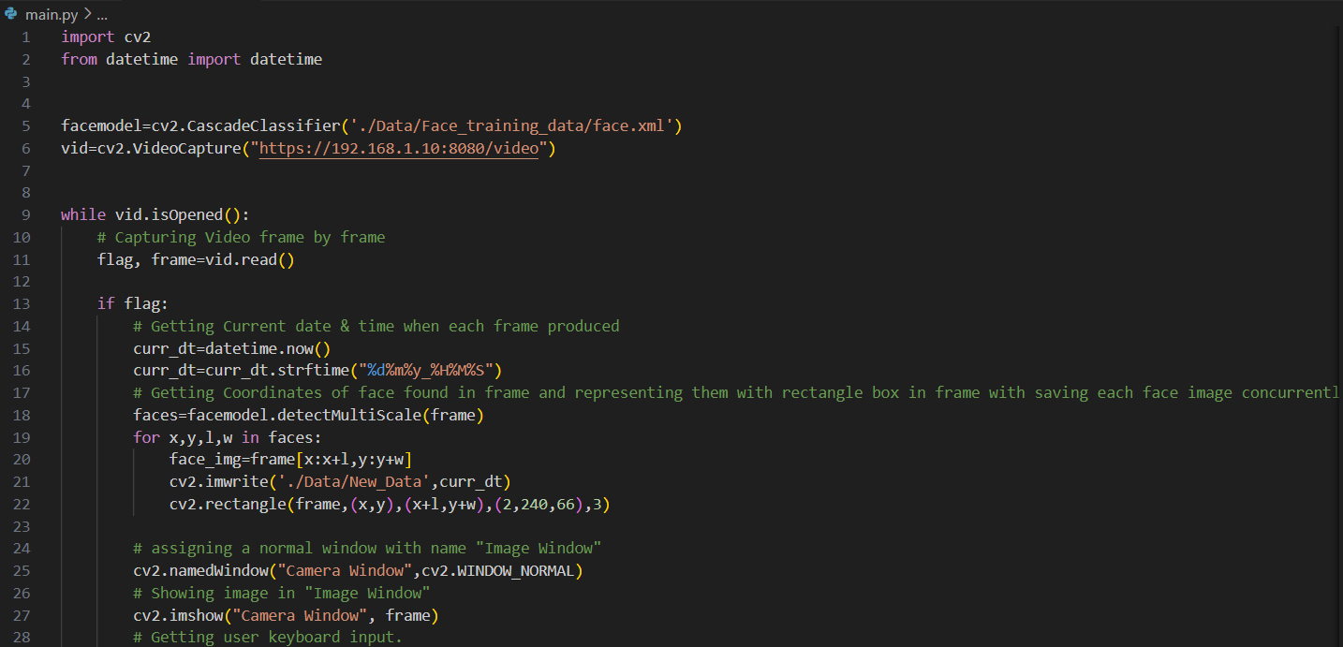 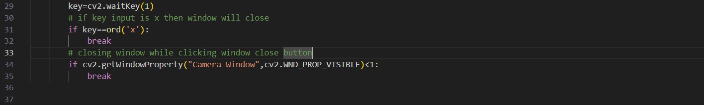

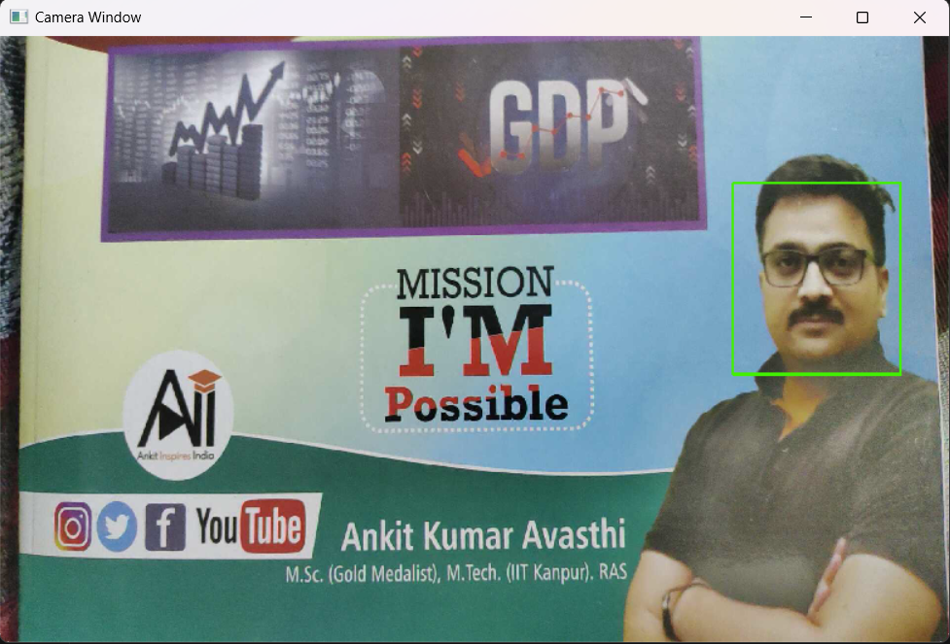

**Model Training**

1. Training Model for Mask Detection

* Installing packages:
  + Pillow
  + Scipy
  + Tensorflow

|  |
| --- |
| pip install pillow scipy tensorflow |

* Training and Saving CNN Model

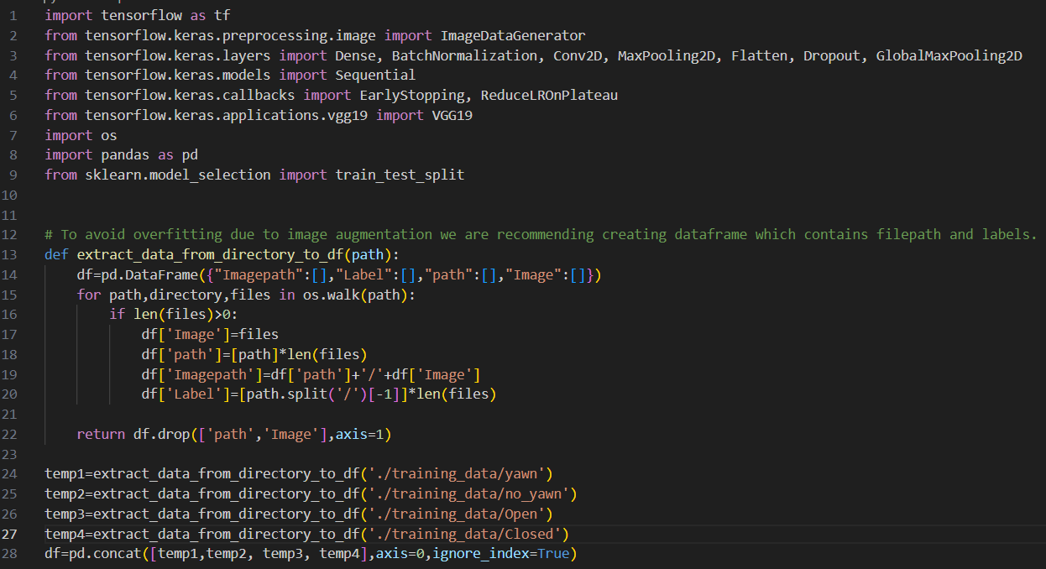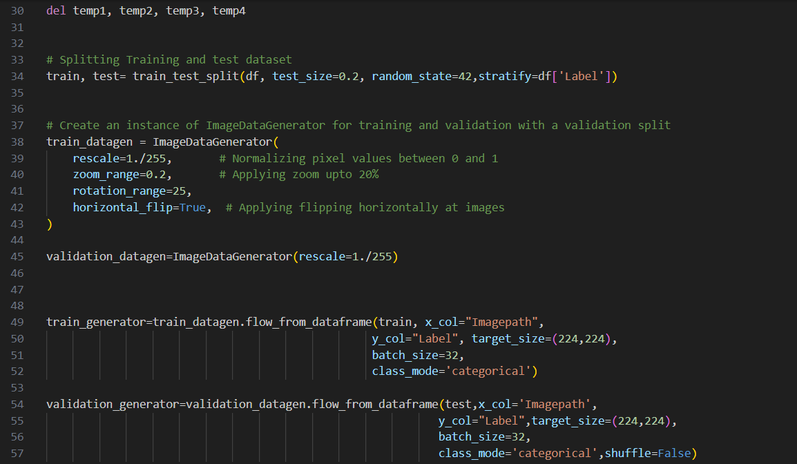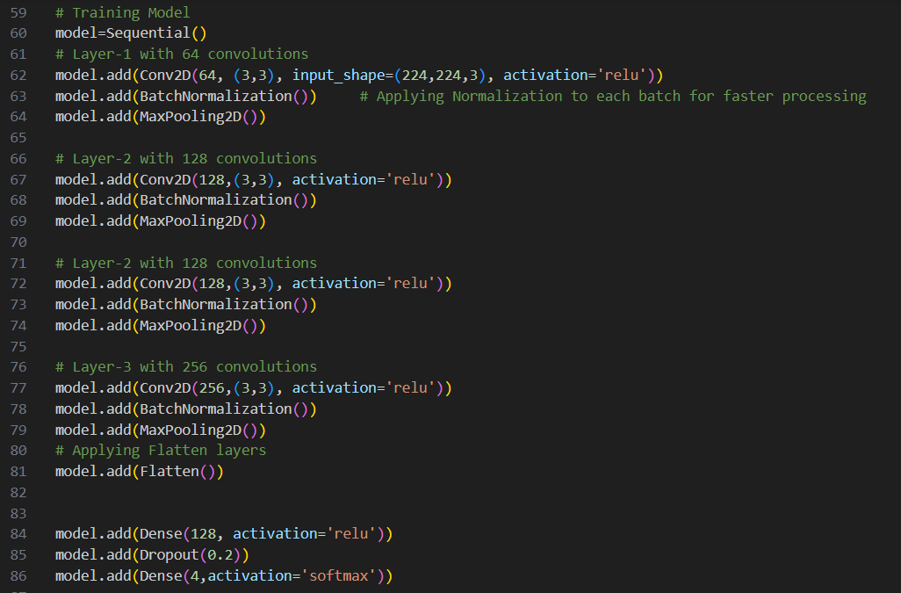

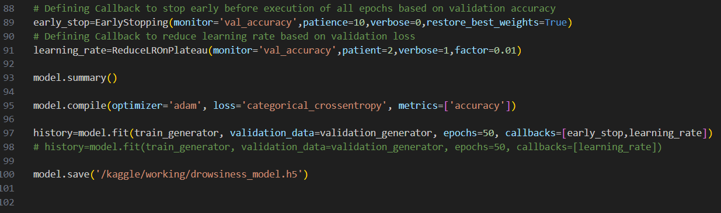

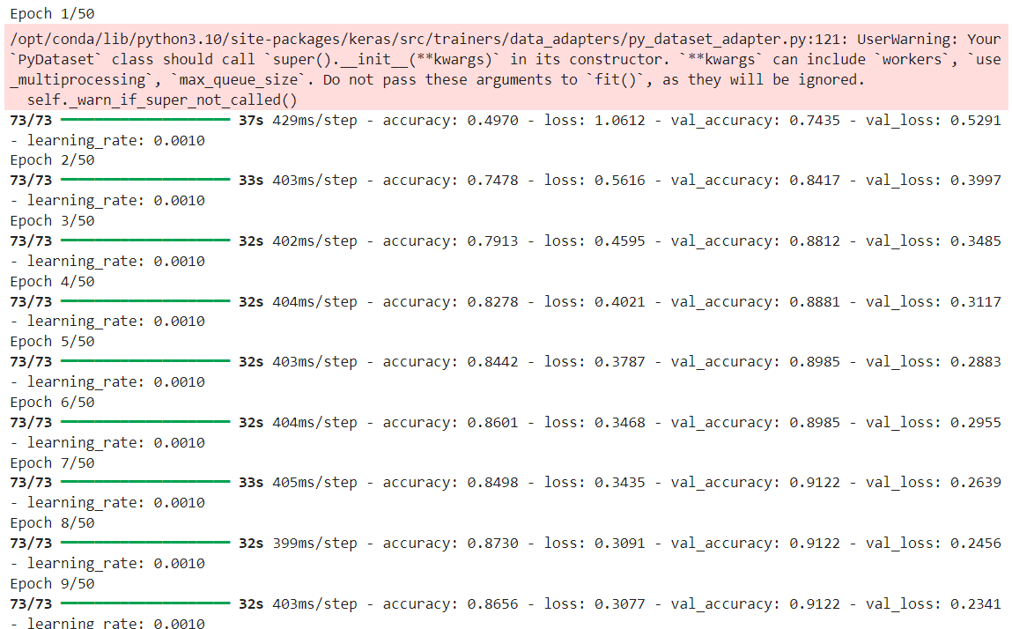

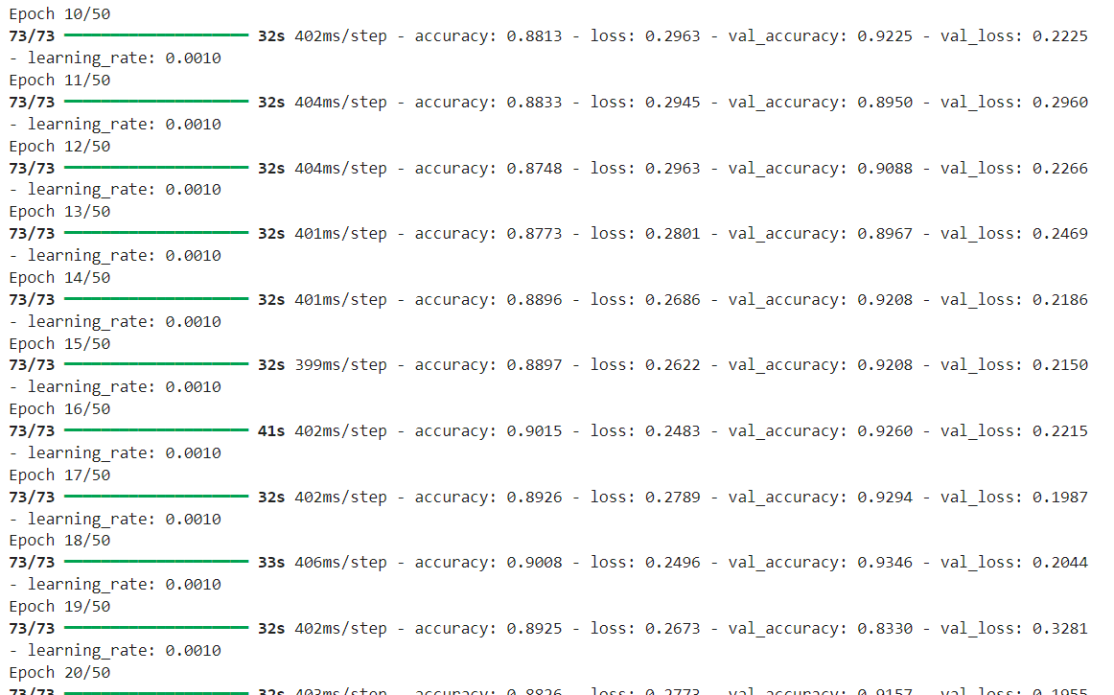

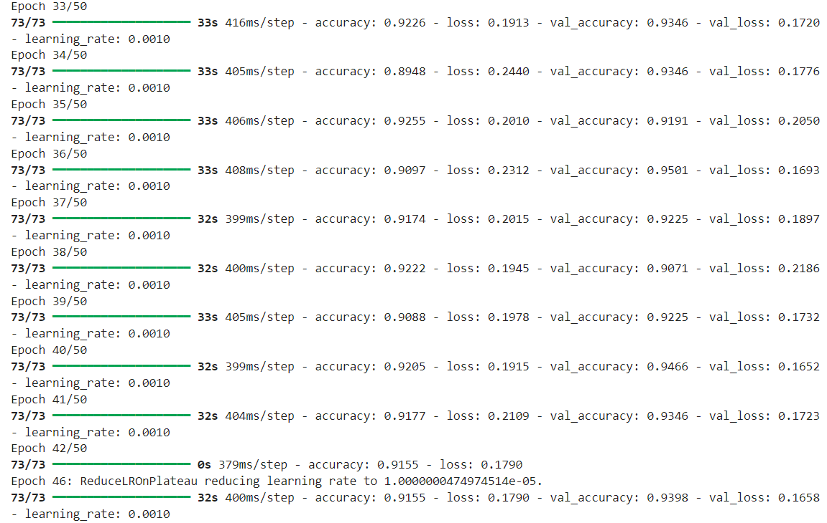

* Detecting Drowsiness from video

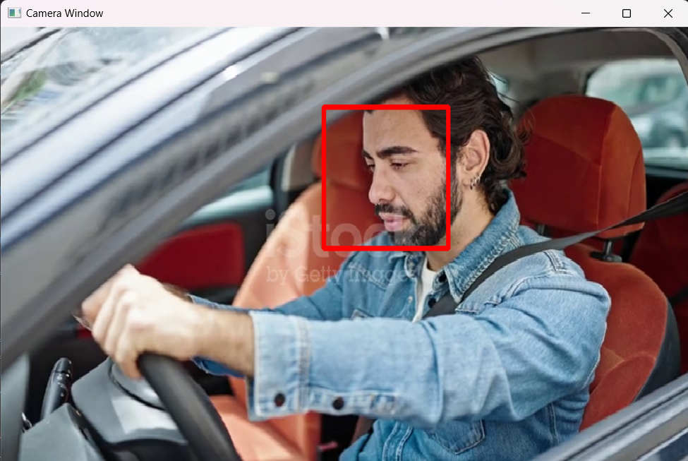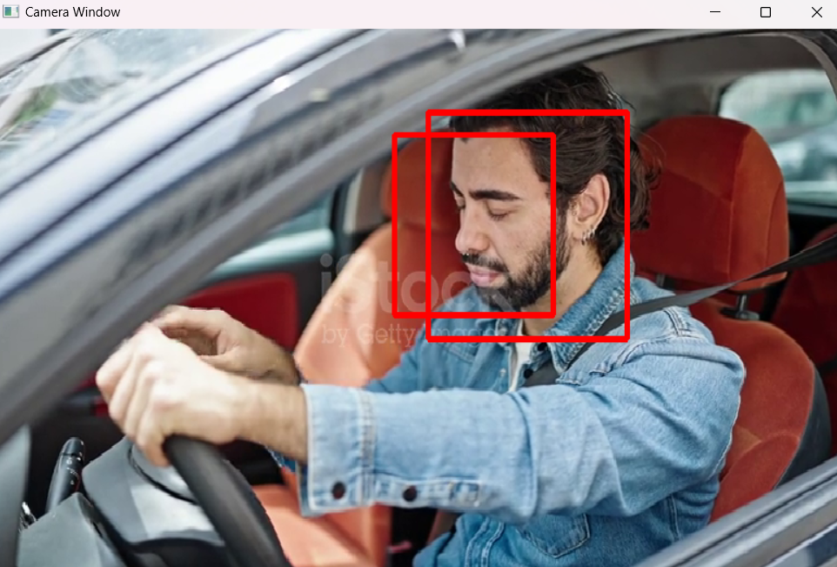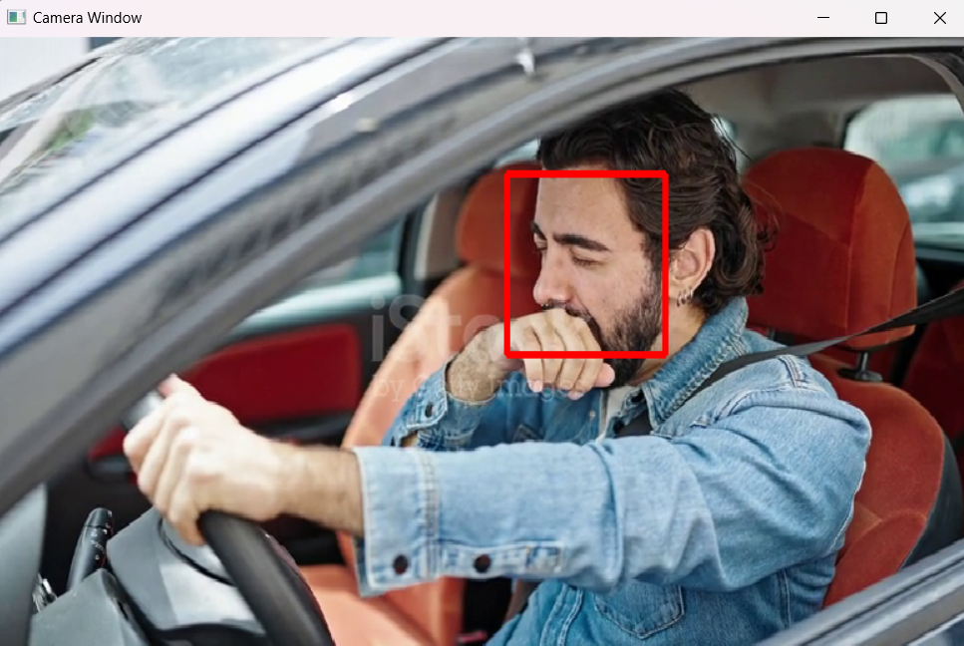

**Note:** Red color rectangle will appear only when drowsiness detected otherwise no rectangle will be shown.

**Creating Frontend for application**

* Installing package:
  + streamlit

|  |
| --- |
| pip install streamlit |

* Code Review

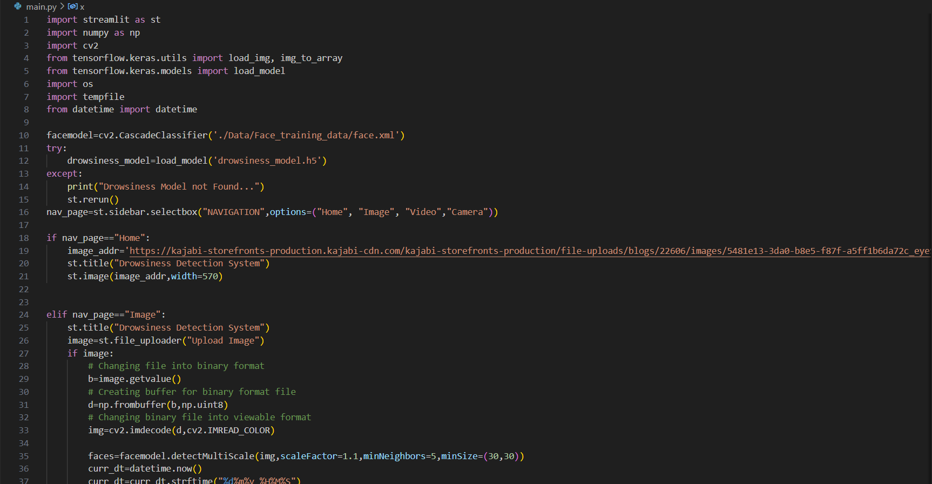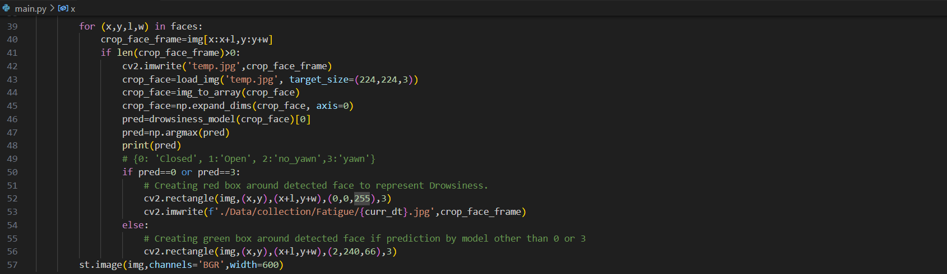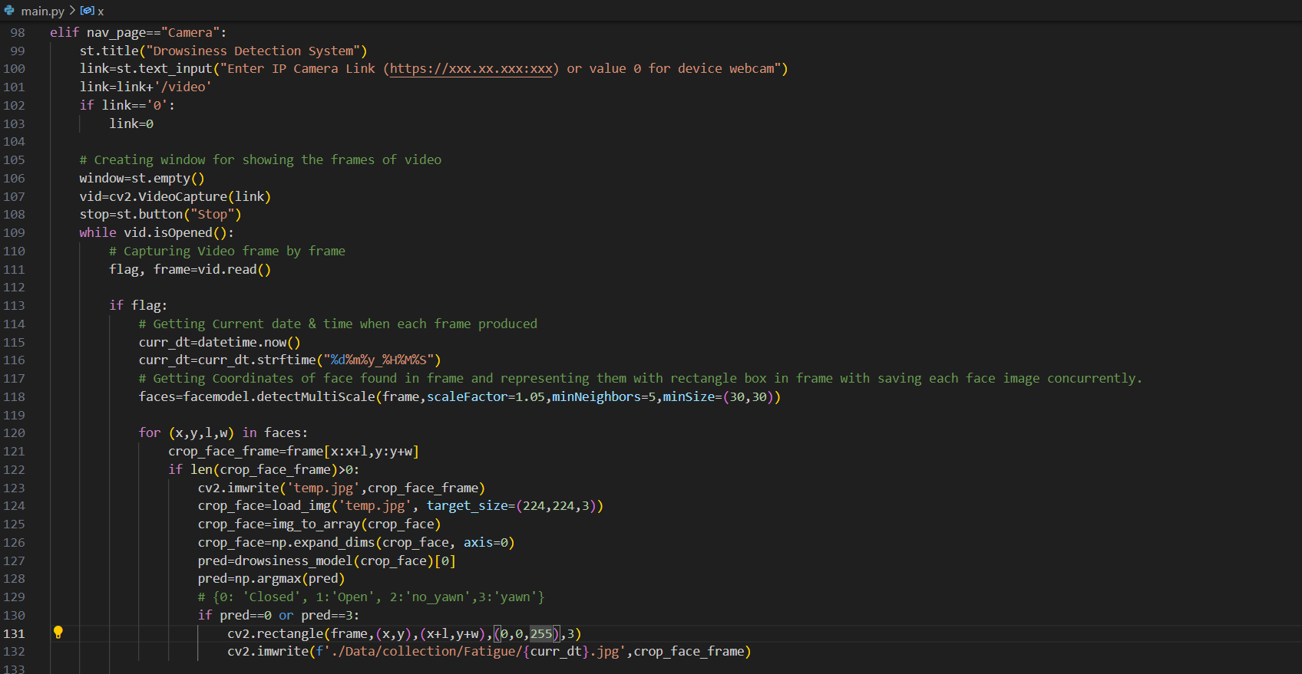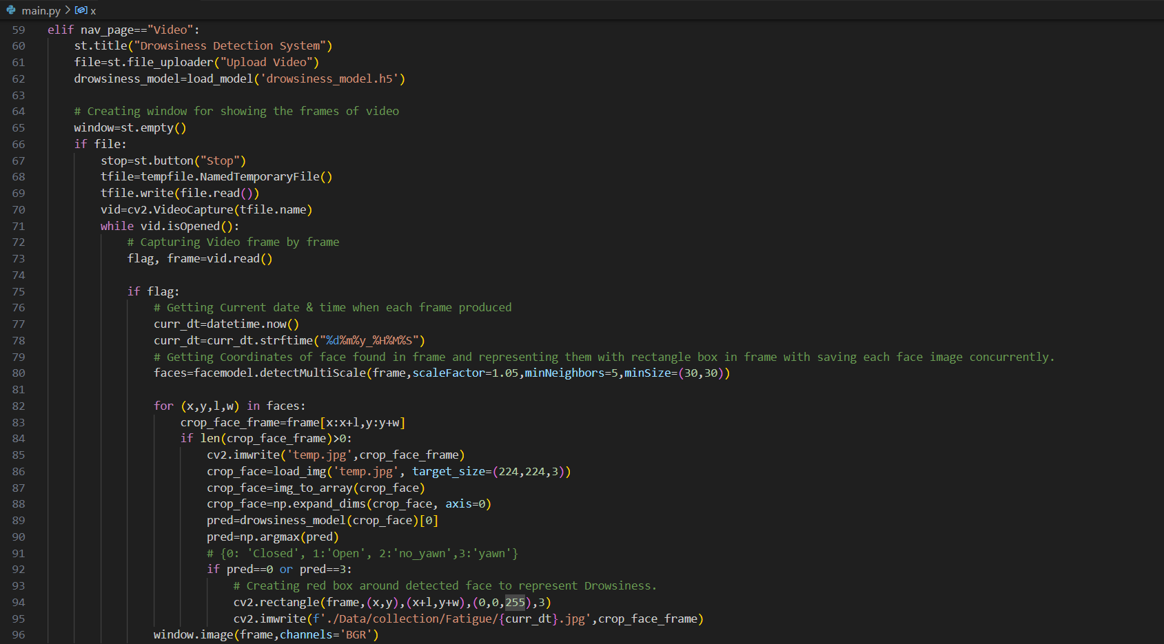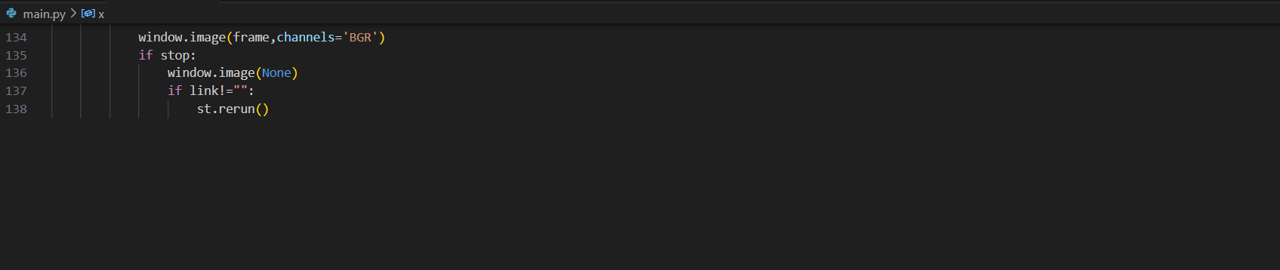

* Home page

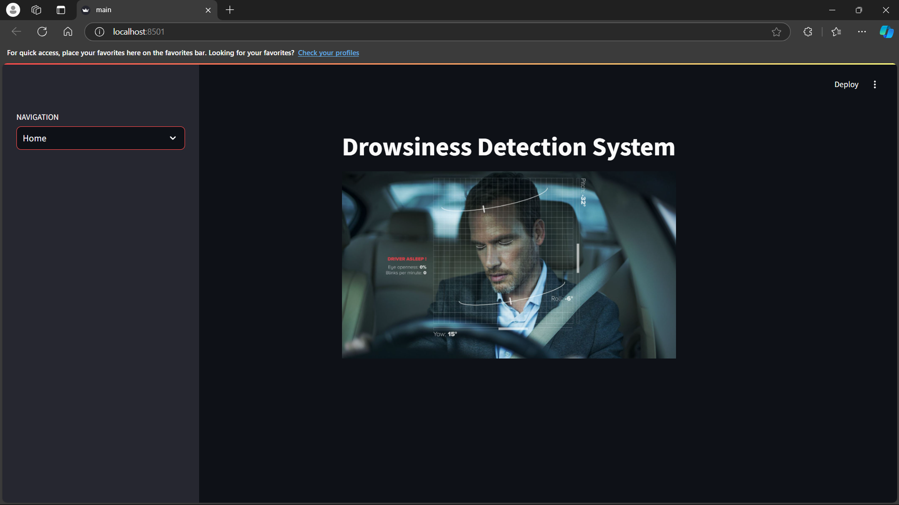

* Drowsiness Detection from Image

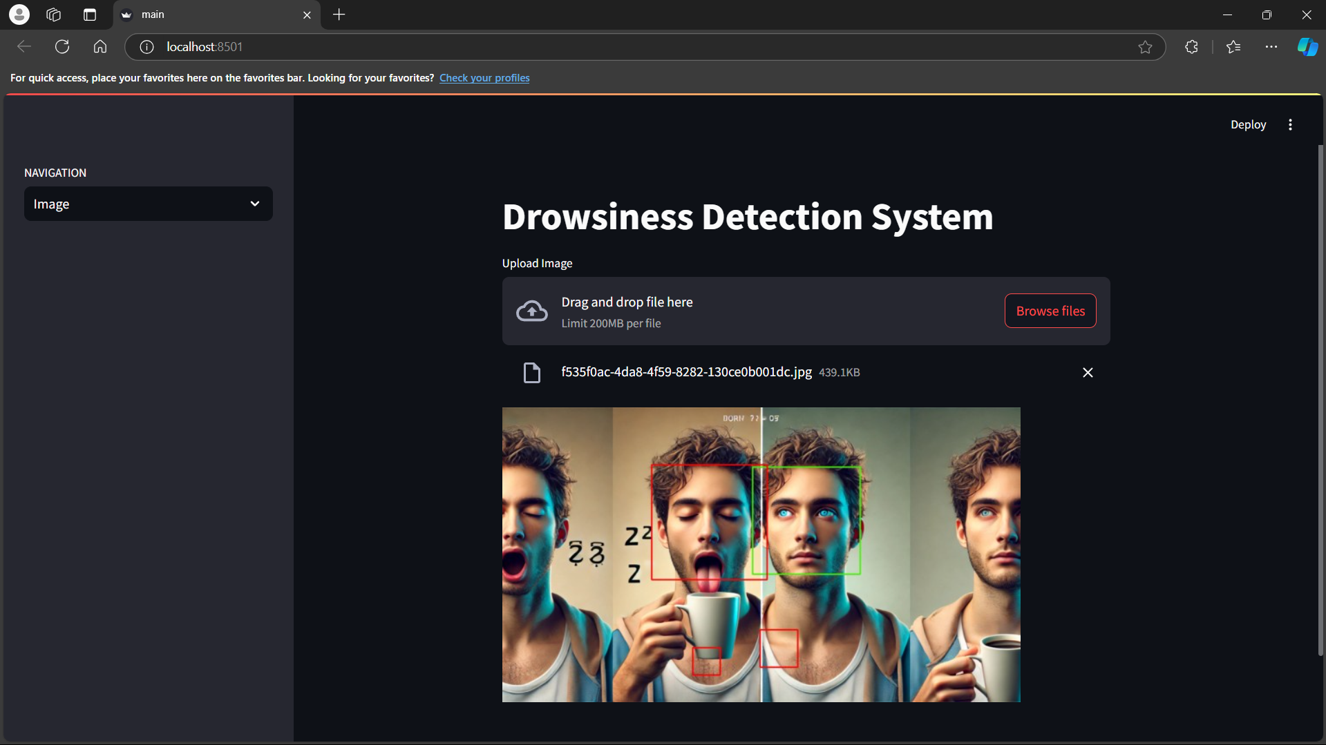

* Drowsiness detection from Video

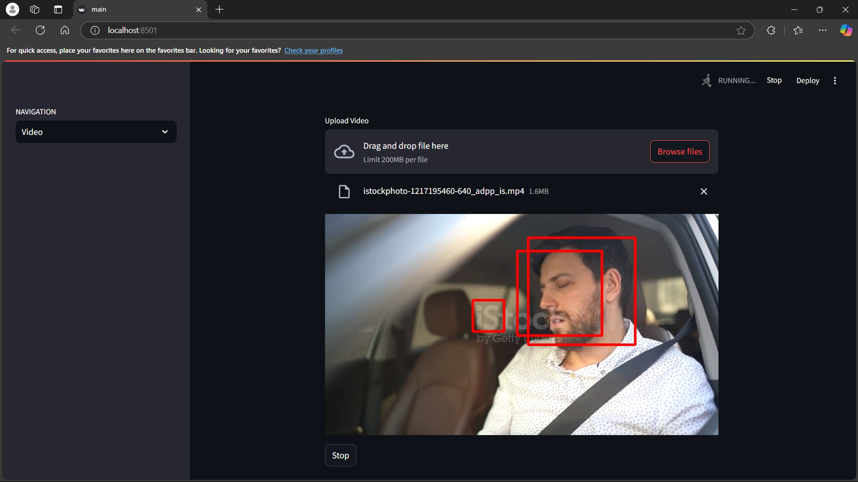

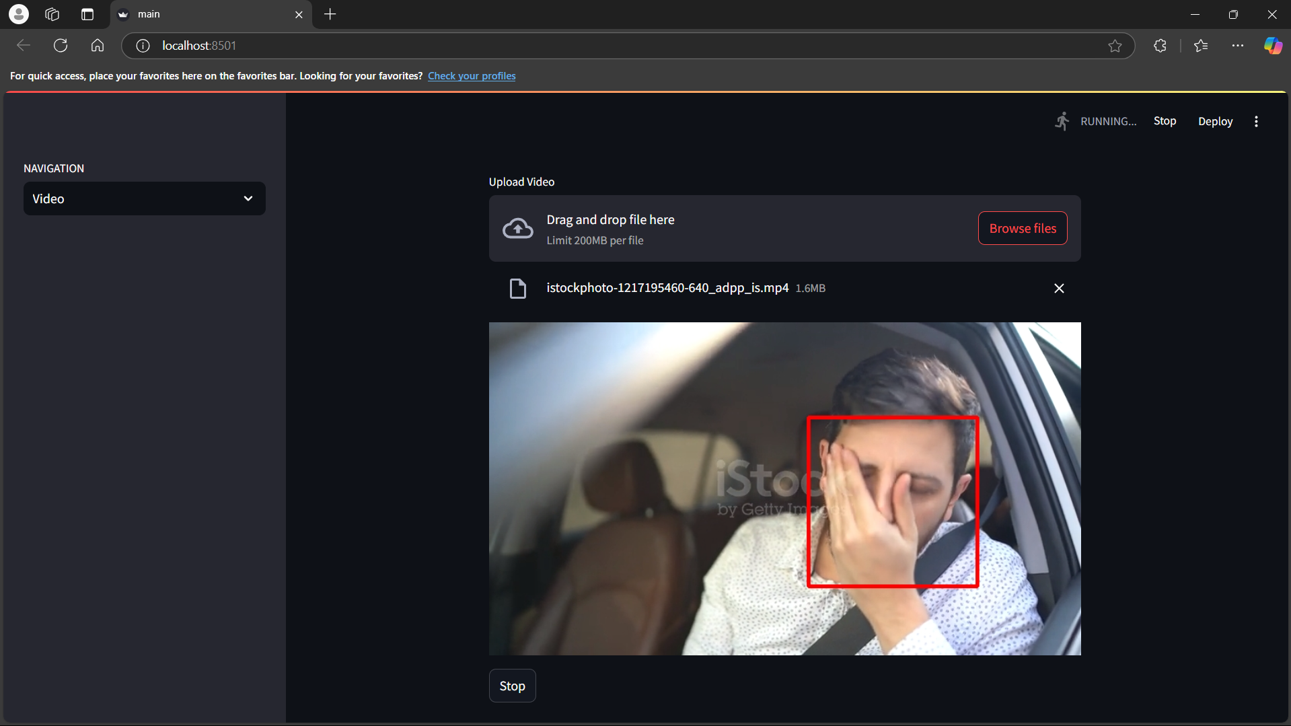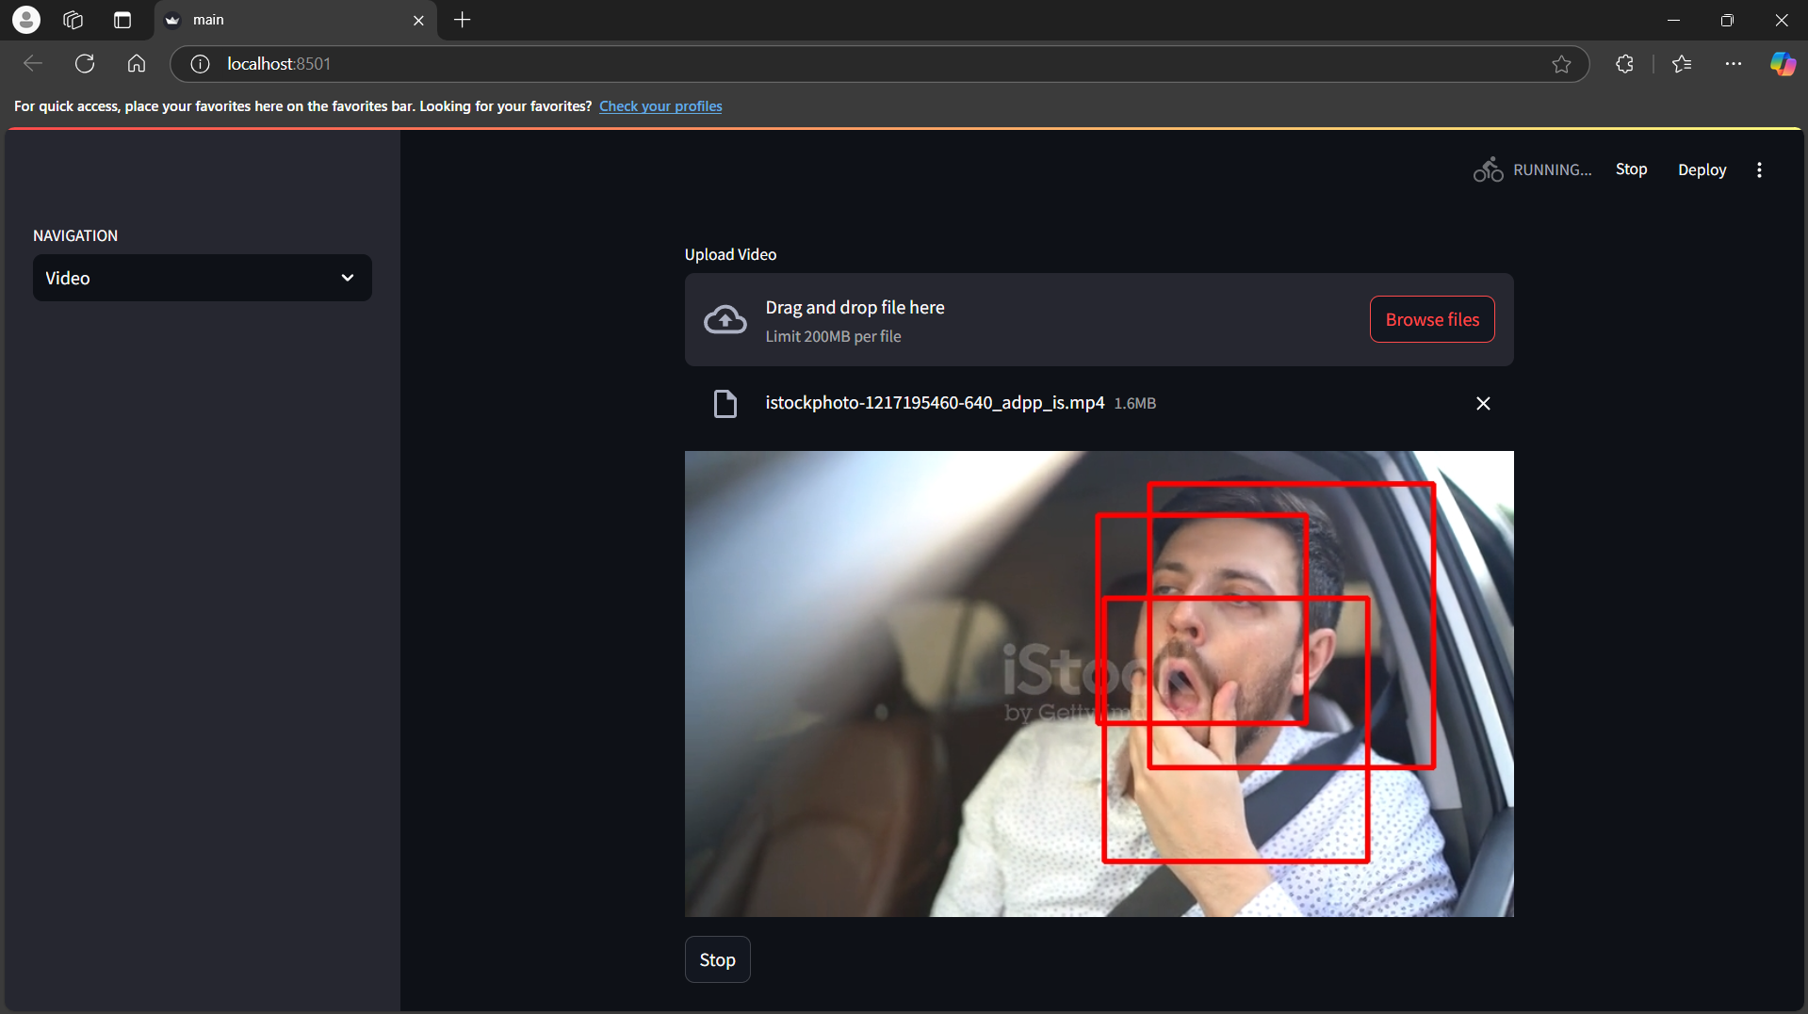

* Drowsiness Detection from Camera

